Class Diagram

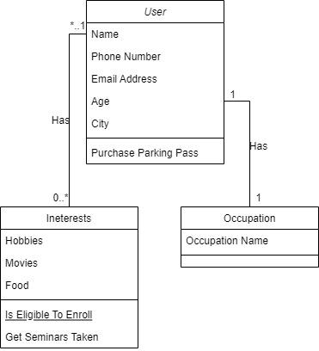

DB Design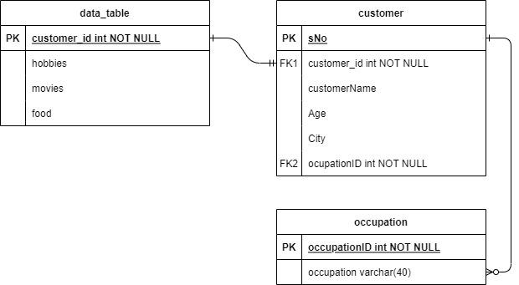

**SQL Database**

create database phase1;

go

use phase1

go

create table occupation(

occupationID int primary key not null,

occupationName varchar(30)

)

go

create table customer(

customerID int primary key,

customerName varchar(30),

age int not null,

city varchar(30) not null,

occupationID int foreign key references occupation(occupationID)

);

go

create table data_table(

customerID int foreign key references customer(customerID),

hobbies varchar(30),

genre varchar(30),

food varchar(30)

);

go

insert into occupation(occupationID, occupationName)

values(001,'Software Engineer'),

(002,'Doctor'),

(003,'Proffessor'),

(004,'Architect'),

(005,'Manager');

go

insert into customer(customerID,customerName,age, city, occupationID)

values (1,'Abhinav', 23, 'Thrissur',001),

(2,'Akshay', 24, 'Palakad',003),

(3,'Robin', 40, 'Thrissur',004),

(4,'Andrew', 28, 'Kochi',002),

(5,'Yash', 30, 'Delhi',005),

(6,'Peter', 33, 'New York',001);

go

insert into data_table(customerID, hobbies, genre, food)

values(1,'Reading','horror', 'pizza'),

(3,'Reading','horror', 'pizza'),

(1,'Painting','romcom', 'Biriyani'),

(1,'Cycling','action', 'pasta'),

(2,'Dancing','sci-fi', 'butter chicken'),

(2,'Painting','horror', 'Burger'),

(3,'Cycling','action', 'Biriyani'),

(4,'Reading','horror', 'pasta'),

(5,'Dancing','comedy', 'butter chicken'),

(5,'Painting','horror', 'Burger'),

(5,'Reading','action', 'ice cream'),

(6,'Reading','horror', 'ice cream');

go

**QUERIES**

—-----------------1—------------------

select top 1 hobbies as 'most prefered hobby' from data_table

group by hobbies

order by count(*) desc

Output

most prefered hobby

Reading

—----------------------2—-----------------------------

select customer.customerName, count(food) as 'favorite food'

from data_table

join customer on data_table.customerID = customer.customerID

group by customerName

having count(food) >1;

Output

customerName favorite food

Abhinav 3

Akshay 2

Robin 2

Yash 3

—-------------------------------3—--------------------------------------------

select customerName, age, city

from customer

join data_table on customer.customerID = data_table.customerID

where age > = 40

and genre = 'Horror'

AND food = 'Pizza'

Output

customerName age city

Robin 40 Thrissur

**MongoDB**

—------------------creating database—---------------

test> use phase1

switched to db phase1

—------------------creating and inserting values into a collection—------------------

phase1> db.collection.insertMany(

... [{"id" : 1,

..... "name":"Abhinav",

..... "age":23,

..... "hobbies":["Reading","Walking","Painting"],

..... "food":["Biriyani","Pizza","Burger"],

..... "genre":["romcom","Horror"]

..... ,"city":"Kochi",

..... "occupation":"Engineer"},

... {"id":2,

..... "name":"Akshay",

..... "age":34,

..... "hobbies":["Walking","Painting"],

..... "food":["Pasta","Biriyani"],

..... "genre":["action","sci-fi"],

..... "city":"Trivandrum",

..... "occupation":"Manager"},

... {"id":3,

..... "name":"Andrew",

..... "age":25,

..... "hobbies":["Reading","Dancing"],

..... "food":["Pasta","Pizza"],

..... "genre":["Horror"],

..... "city":"Delhi",

..... "occupation":"Architect"},

... {"id":4,

..... "name":"Peter",

..... "age":41,

..... "hobbies":["Walking","Singing"],

..... "food":["Biriyani","Burger"],

..... "genre":["action","comedy"],

..... "city":"New York",

..... "occupation":"Doctor"},

... {"id":5,

..... "name":"Bruce",

..... "age":28,

..... "hobbies":["Boxing","Singing"],

..... "food":["Pizza","Pasta"],

..... "genre":["action","sci-fi"],

..... "city":"Gotham",

..... "occupation":"Vigilante"}])

{

acknowledged: true,

insertedIds: {

'0': ObjectId("61de8183794333038f48efff"),

'1': ObjectId("61de8183794333038f48f000"),

'2': ObjectId("61de8183794333038f48f001"),

'3': ObjectId("61de8183794333038f48f002"),

'4': ObjectId("61de8183794333038f48f003")

}

}

—---------------------------------------2—--------------display the last client id—-------------

phase1> db.collection.find().sort({id:-1}).limit(1);

Output

[

{

_id: ObjectId("61de8183794333038f48f003"),

id: 5,

name: 'Bruce',

age: 28,

hobbies: [ 'Boxing', 'Singing' ],

food: [ 'Pizza', 'Pasta' ],

genre: [ 'action', 'sci-fi' ],

city: 'Gotham',

occupation: 'Vigilante'

}

]